Wellesley Calculation Policy

Progression In Addition – always check using the inverse |  | Manipulatives | Progression in Subtraction – always check using the inverse
EYFS  Year 1 | Symbols/Pictures  8 people are on the bus. 5 more get on at the next stop. How many people are on the bus now?  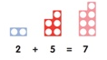  [Might be recorded as: 8 + 5 = 13] | Counters  Number lines  Numicon  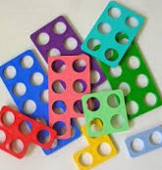 | Symbols and Pictures  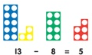  Mum baked 9 biscuits. I ate 5. How many were left?  Might be recorded as: 9 – 5 = 4]
Year 1  Year 2 | Number track / Number line and Beads  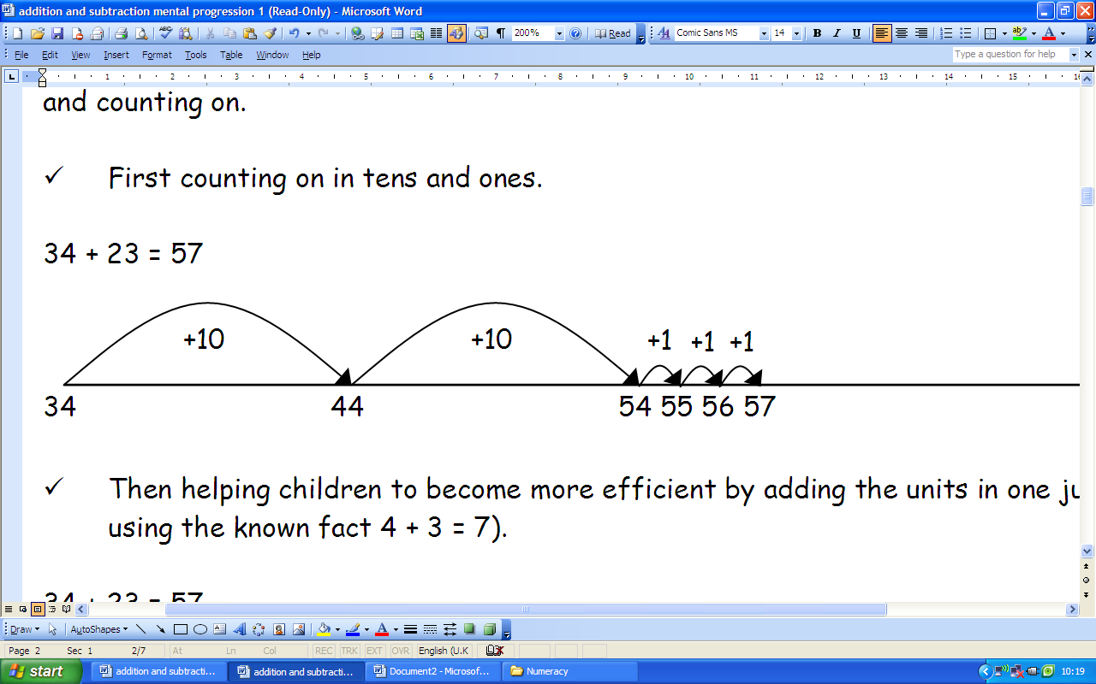  18 + 5 = 23  +1 +1 +1 +1 +1  18 19 20 21 22 23 24 | Counters  Number lines  Numicon  Bead String  Dienes   | Number track / Number line and Beads  13 – 5 =8  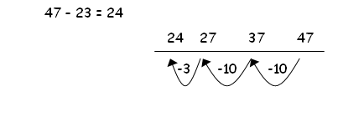  8 9 10 11 12 13  -1 -1 -1 -1 -1
KS2 | Column Addition - Expand to include decimals  Model partitioning for expanded written method first.  Use the language of carrying  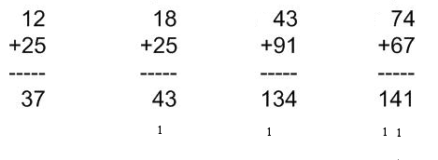 | Dienes  Place Value Counters  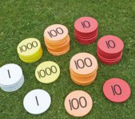  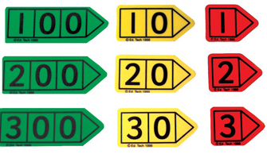  Place Value Cards | Column Subtraction- Expand to include decimals  Use the language of exchanging  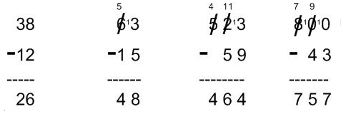

EYFS | Year 1 | Year 2 | Year 3 | Year 4 | Year 5 | Year 6
There are 3 blue cars and 3 red cars. How many cars altogether ?  There are 3 red cars and 4 blue cars ? How many more blue cars than red cars ? | May buys 8 red apples and 6 green apples from the fruit shop.  How many apples does she buy altogether?  Rebeena has 8 ice lollies. She gives 5 to her friends. How many  does Rebeena have left? | Victoria has drawn 10 pictures in her sketch pad. Javeria has also  drawn 10 pictures. How many pictures have they drawn altogether?  Alfie buys a lolly for 12p and a packet of crisps for 20p. How  much money has he spent? | Alicia collected 97 badges. Her mum bought her 45 more badges. How  many badges does she have now?  Alicia collected 97 badges. She gave 53 away to her friend. How many has she got left ? | At a netball match, there are 126 people supporting the blue team and  178 supporting the yellow team. How many people are watching the  game altogether?  Tom , sells 1535 pies on Monday and 1219 on Tuesday.  How many more pies did he sell on Monday compared to Tuesday ? | There are 3257 people at the rugby match. This is 1138 people more than  last week. How many people were at the match last week?  There were 5834 guests staying at the holiday resort during one week.  The next week, there were 3425 guests staying. How many more people  stayed at the resort during the first week? | There are 1250 letters in Post Box A and 2350 letters in Post Box B.  a) How many letters are there altogether?  b) The postman delivers 2640 letters. How many letters still need to  be delivered?

Progression In Multiplication – always check using the inverse |  | Manipulatives | Progression in Division – always check using the inverse
EYFS  Y1 | Symbols/pictures/objects  3 lots of 2 sticks. = 3 x 2  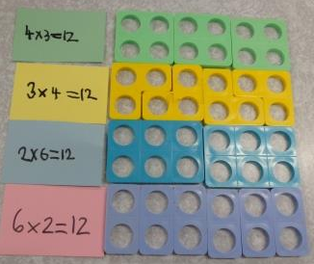  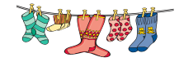  5 lots of 2 socks  5 x 2 = 10 | Counters  Number lines  Numicon | 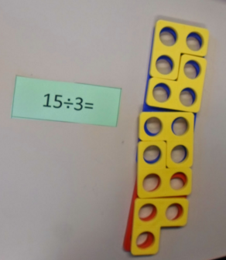  Symbols/pictures/objects  4 sticks shared between 2 children.  Grouping : How many groups of 2 in 4?
Y1  Y4 | Repeated addition Arrays 5 x 3 or 3 x 5  Number lines  5 x 3 or 3 x 5  0 3 6 9 12 15  0 5 10 15 | Counters  Number lines  Numicon  Bead String  Dienes | Repeated subtraction  Number lines  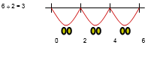  15 ÷ 5  24 ÷ 5 = 4 r4  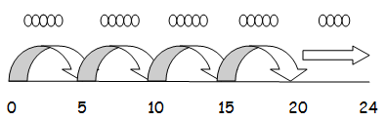
Y1  Y4 | Short method – ensure pupils can partition into tens and ones before introducing grid  Expand to include decimals  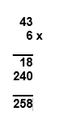  Grid Expanded Compact  1  4 3  6 x  2 5 8  43 x 6 | Dienes, numicon  Place Value Counters   | Short method – chunking then move to compact  Expand to include decimals  Compact    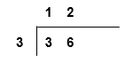  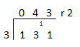
  x | 6
  3 | 18
  40 | 240
   | 258
Y5  Y6 | Long method  Expand to include decimals  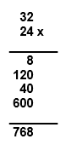  Expanded Compact  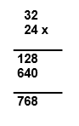 |  | Long Method  Expand to include decimals  Use the language of exchanging  (25 x 20)  (25 x 3)
   | H  3 | T  6 | U
  X | 1 | 4 | 8
   |  | 4 | 8
  1 | 1 | 8 | 4
  5 | 9 | 2 | 0
  1 | 3
  7 | 1 | 0 | 4
  1 | 1
   |  | 0 | 2 | 3. | 1 | 2
  2 | 5 | 5 | 7 | 8. | 0 | 0
   |  | 5 | 0 |  |  |  |  | (2 | 5 | x | 2)
   |  | 0 | 7 | 8
   |  |  | 7 | 5 |  |  |  | (2 | 5 | x | 3)
   |  |  | 0 | 3 | 0
   |  |  |  | 2 | 5 |  |  | (2 | 5 | x | 1)
   |  |  |  | 0 | 5 | 0
   |  |  |  |  | 5 | 0 |  | (2 | 5 | x | 2)
   |  |  |  |  | 0 | 0
   |  | 0 | 2 | 3 | R | 3
  2 | 5 | 5 | 7 | 8
   |  | 5 | 0 | 0
   |  | 0 | 7 | 8
   |  |  | 7 | 5
   |  |  | 0 | 3

EYFS | Year 1 | Year 2 | Year 3 | Year 4 | Year 5 | Year 6
Make the socks into pairs. How many pairs have you got ?  Share the 10 sweets between you and your friend. | Liam counts on in fives from the number 22. What are the next 2  numbers he counts?  Poppy eats 6 grapes. Alice eats half as many. How many  grapes does Alice eat? | 2 teams are playing basketball. There are 5 players in each team.  How many people are playing basketball altogether?  15 sweets, shared between 5 . How many each ? | One bag holds 4 tomatoes. How many tomatoes are in 2 bags?  I have 48 apples, how many can each child have if there are 8 children in the group ? | Charlotte drew a line 3 cmlong. Then she made the line 3 times longer.  How long would 6 of these longer lines be, drawn end to end?  Dominic’s grandma and grandad always give him £36 on his birthday. He shares this between 5 friends ? How much does he have left over ? | In Mr Pott’s garden, there are 7 rows of tomato plants. Each row has 435  tomato plants. How many tomato plants are in the garden altogether?  There are 386 apples that need to be put into boxes containing 5 apples  per box. How many full boxes of apples can be made altogether? How  many apples are left? | There are 98 junior children in Daisyhill School. In assembly, children sit in  rows of 18.  a) How many full rows can be made?  b) How many children are left over?  We need 143 rows of chairs. Each row needs 19 chairs. How many chairs are needed ?

